

**Asset Practice Questions: Mathematics**

1. In Mihir's class, students sit in order according to their roll number. The places of Roll number 1 to

Roll number 12 are shown below.

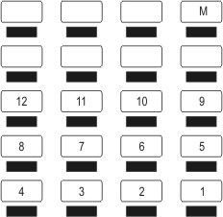

The place marked 'M' is Mihir's seat. What is his roll number?

A. 13

B. 17

C. 20

D. 29

2. Rashi thinks of a number. Anar has to guess Rashi's number.

Rashi gives the following hints to Anar: - The number has 4 as one of its digits. - The number is greater than 300 and less than 400.

Which of these could be Rashi's number?

A. 243

B. 347

C. 396

D. 430

3 Starting from the left, the number cards below have to be arranged from SMALL to BIG. Which number should come just after 262?



A. 431

B. 326

C. 236

D. 226

4. Which of these equals 374?

A. 3 + 7 + 4

B. 30 + 70 + 4

C. 300 + 7 + 40

D. 300 + 4 + 70

5. 3 Tens + 5 Hundreds + 2 Ones is

A. 352

B. 523

C. 253

D. 532

6. Vishal is adding 465 and 319. Shekhar is adding 265 and 319. The answer that Vishal gets will be

A. 2 more than Shekhar's answer.

B. 200 more than Shekhar's answer. C. 200 less than Shekhar's answer. D. 265 more than Shekhar's answer.

7. Which of these is 341 CLOSEST to?

A. 34 ones B. 34 tens C. 43 tens

D. 3 hundreds

8. The number which comes after the smallest three-digit number is

A. 11

B. 99

C. 101

D. 1000

9. What fraction of the vehicles in the picture below are buses?

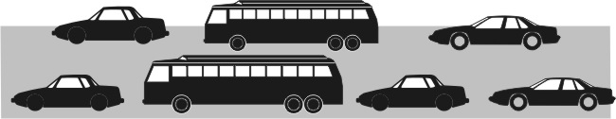

A. 1/2

B. 2/5

C. 2/7

D. 5/7

10.

11.

Into how many equal parts should this circle be divided if EXACTLY ¾ of it has to be shaded?

A. 3

B. 4

C. 5

D. 7



What should come in the empty box to make the number sentence true?

A. =

B. <

C. >

D. We cannot say for sure.

12. I buy 6 bananas and eat half a banana daily. The bananas will be over in

A. 1 day

B. 3 days C. 6 days D. 12 days